ADULTS: MEN, WOMEN, & SENIORS
KOH (Knights of Hope / Men’s Group) 2nd Saturday 8AM at the church knights@hopevabeach.org
LWML (Lutheran Women in Mission League) 3rd Sat. odd months 9:30AM. hopeVABeachLWML@gmail.com
Thursday Evening Ladies’ Bible Study 1st & 3rd Thursday 7PM
LEISURE LUTHERANS (Seniors’ Group) Lunch out the 3rd Monday Sep-Jun; locations vary
BIBLE STUDY WITH PASTOR Wednesday mornings at 10:30 AM each week in Main-1

YOUTH See calendar for special events youth@hopevabeach.org
OASIS (youth group) grades 6-12, LENT Schedule: 5:00PM-7:00PM 2nd & 4th Sundays.
Regular Schedule: 6:30PM 2nd & 4th Wednesdays
FIRST COMMUNION CLASS (grade 6 or older) Sept-Nov: 1st & 3rd Wednesday evenings w/Pastor
CONFIRMATION CLASS (grade 8 or older) Year Long Program starting in September

PARENTS ckaczmarek@hopevabeach.org
KIDS PRAISE Children’s church for those aged 3 through 3rd grade during the 11AM Sunday
service. Children must be signed in so please escort your child to the narthex
KIDS WOW: An afternoon of fun for children aged 3 through 5th grade while parents enjoy
some time away. Meets one Sunday afternoon per month, see calendar for dates.

MUSICIANS
PRAISE TEAM Practice 7:00 PM Tuesdays bcmason@hopevabeach.org
ADULT VOCAL CHOIR Practice 7:30 PM Wednesdays bcmason@hopevabeach.org
YOUTH BELL CHOIR Practice 6:30 PM Thursdays ahusna86@gmail.com/757-343-2988
ADULT BELL CHOIR Practice 7:00 PM Thursdays ahusna86@gmail.com/757-343-2988
SPECIAL MUSIC Share your talents! Call the office to coordinate:. connect@hopeVABeach.org

OUR SCHOOL: HOPE ACADEMY
Christian Education and Child Care in Virginia Beach: www.HopeAcademyVB.org
Providing an environment where children from birth to kindergarten can grow, learn, & meet Christ.

SOCIAL MINISTRY – See the Seek Wall in the Narthex for ministry updates!
FOOD PANTRY Open 2nd & 4th Wednesdays 6pm-7pm and 2nd & 4th Saturday 10am-11am.
MOTHER’S PANTRY fulfilling the tangible needs of mothers & babies (open with food pantry)

Save the Dates:
April 12-14 Southeastern District Middle School Retreat
April 19-21 Knights of Hope Men’s Retreat
May 2 National Day of Prayer

March, 2024
5350 Providence Road, Virginia Beach, VA 23464
HopeVABeach.org / 757-424-4848
SUNDAY MORNINGS; Nursery provided Church Office Hours 9:00 AM–4:00 PM, Mon–Fri
8:15AM Traditional, 11:00AM Contemporary
9:45AM Sunday School for all ages

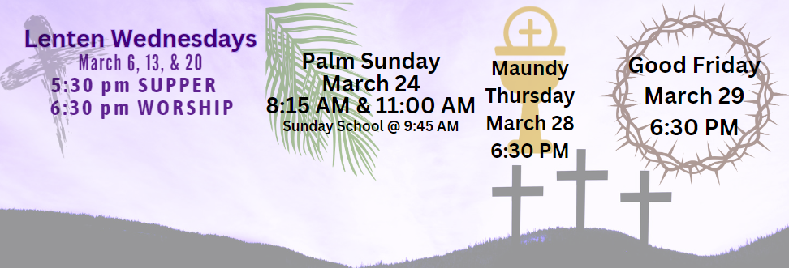

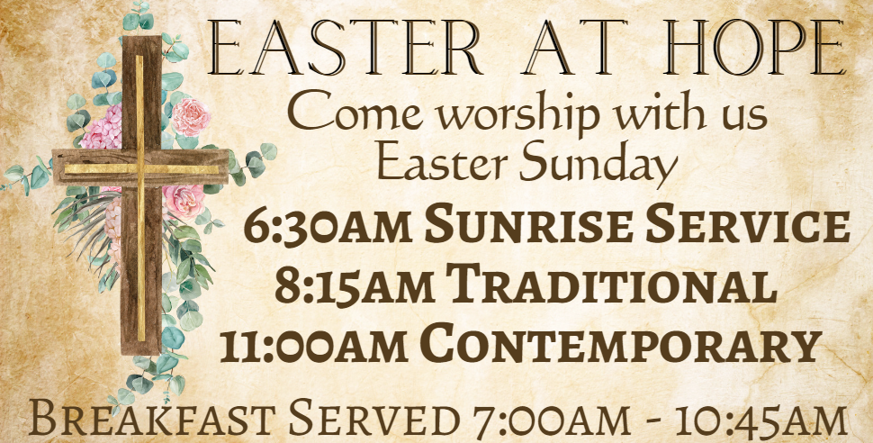

SUN | MON | TUES | WED | THURS | FRI | SAT
March 3  8:15AM Worship  9:45AM Sunday School  11:00AM Worship  Social Ministry Easter Basket Donation Collection Begins  Easter Lilies available to be sponsored | 4 | 5  7:00PM HPT Practice | 6  10:30 AM Bible Study  5:30PM Lenten Supper  6:30PM Lenten Worship  7:15 Choir Practice | 7  NO Chimes Practice  Chimes will resume Apr 11  NO Hand Bells Practice  7:00PM Ladies Bible Study | 8 | 9  8:00 AM KOH Breakfast  & Bible Study  10-11AM Food Pantry Open  6PM Youth: Admiral’s Game
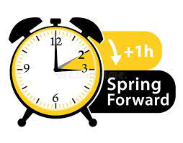  10 KOH  DST Begins!  8:15AM Worship  9:45AM Sunday School  New Members Class Begins!  11:00AM Worship  5:00PM-7:00PM Youth OASIS | 11 | 12  7:00PM HPT Practice | 13  10:30 AM Bible Study  6PM-7PM Food Pantry Open  5:30PM Lenten Supper  6:30PM Lenten Worship  7:15 PM Choir Practice | 14  NO Chimes Practice  7:00 PM Hand Bells Practice | 15  NO Youth Movie Night  (will be rescheduled) | 16  9:00AM LWML Meeting
17 Mites  8:15AM Worship  9:45AM Sunday School  11:00AM Worship | 18  11:30 LL Lunch | 19  6:30PM Council Meeting  7:00PM HPT Practice | 20  10:30 AM Bible Study  5:30PM Lenten Supper  6:30PM Lenten Worship  7:15 PM Choir Practice | 21  NO Chimes Practice  7:00 PM Hand Bells Practice  7:00PM Ladies Bible Study | 22 | 23  10-11AM Food Pantry Open
24 Palm Sunday  8:15AM Worship  9:45AM Sunday School  11:00AM Worship  5:00PM-7:00PM Youth OASIS  Easter Basket Donations Due | 25 | 26  7:00PM HPT Practice | 27  10:30 AM Bible Study  6PM-7PM Food Pantry Open  6:30PM Brass Practice  NO LENTEN SERVICE  7:30 PM Choir Practice | 28 Maundy Thursday  6:30PM Worship with  Communion  No Bells/Chimes Practice | 29 Good Friday  6:30PM Tenebrae Service | 30 Holy Saturday
31 EASTER!  6:30AM Sunrise Service  in Prayer Garden  7AM-10:45AM Breakfast  8:15AM Traditional Worship  9:45AM NO Sunday School  11:00AM Contemp. Worship | April 1  Office Closed | 2  7:00PM HPT Practice | 3  10:30 AM Bible Study  NO Choir Practice | 4  NO Chimes Practice  NO Hand Bells Practice  7:00PM Ladies Bible Study | 5 | 6
Key to Calendar:
Chimes = Youth Chimes Choir
Bells = Bell Choir
Choir = Adult Vocal Choir
HPT = Hope Praise Team
OASIS = Youth (Middle & High School)
KOH = Knights of Hope (Men’s Group)
LL = Leisure Lutherans (Seniors’ Group)
LWML = Lutheran Women’s Mission League

